**Mega stone Localization**

**Font: Destvol  
Exclusive Pokémon Saves**

[**Charizard**](https://bulbapedia.bulbagarden.net/wiki/Charizard_(Pok%C3%A9mon)) **Y**

**115road  
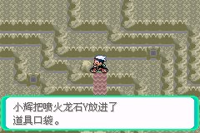**

[**Venusaur**](https://bulbapedia.bulbagarden.net/wiki/Venusaur_(Pok%C3%A9mon)) **stone**

**115road  
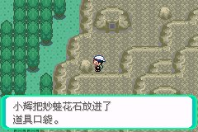**

[**Charizard**](https://bulbapedia.bulbagarden.net/wiki/Charizard_(Pok%C3%A9mon)) **X**

**Scorched Slab**

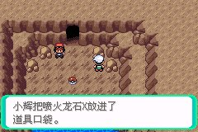

[**Blastoise**](https://bulbapedia.bulbagarden.net/wiki/Blastoise_(Pok%C3%A9mon)) **stone**

**Road 115**

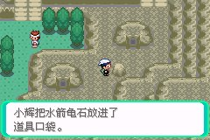

[**Beedrill**](https://bulbapedia.bulbagarden.net/wiki/Beedrill_(Pok%C3%A9mon)) **stone**

**Abandoned Ship**

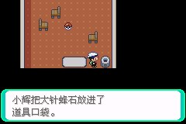

[**Pidgeot**](https://bulbapedia.bulbagarden.net/wiki/Pidgeot_(Pok%C3%A9mon)) **stone**

**Devon Corporation 2f**

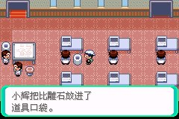

[**Alakazam**](https://bulbapedia.bulbagarden.net/wiki/Alakazam_(Pok%C3%A9mon)) **stone**

**胡弟石**

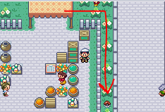

[**Slowbro**](https://bulbapedia.bulbagarden.net/wiki/Slowbro_(Pok%C3%A9mon)) **stone**

**Shoal Cave 1f**

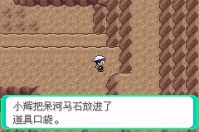

[**Gengar**](https://bulbapedia.bulbagarden.net/wiki/Gengar_(Pok%C3%A9mon)) **stone**

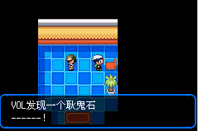

[**Kangaskhan**](https://bulbapedia.bulbagarden.net/wiki/Kangaskhan_(Pok%C3%A9mon)) **stone**



[**Pinsir**](https://bulbapedia.bulbagarden.net/wiki/Pinsir_(Pok%C3%A9mon)) **stone**

**Mossdeep City left side**

**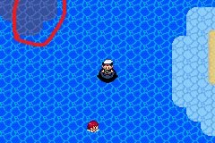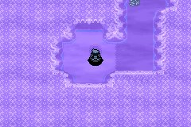  
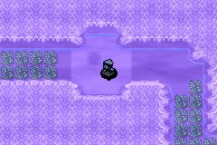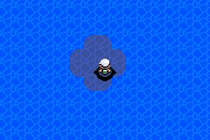  
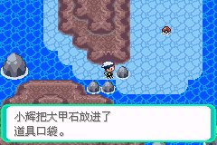**

[**Gyarados**](https://bulbapedia.bulbagarden.net/wiki/Gyarados_(Pok%C3%A9mon)) **stone**

**Road 123**

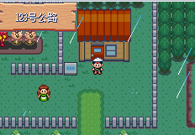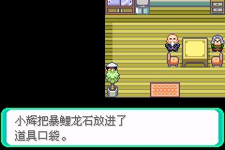

[**Aerodactyl**](https://bulbapedia.bulbagarden.net/wiki/Aerodactyl_(Pok%C3%A9mon)) **stone**

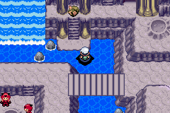

[**Ampharos**](https://bulbapedia.bulbagarden.net/wiki/Ampharos_(Pok%C3%A9mon)) **stone**

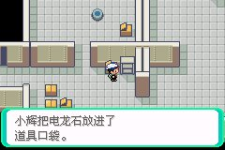

[**Mewtwo**](https://bulbapedia.bulbagarden.net/wiki/Mewtwo_(Pok%C3%A9mon)) **XY stone**

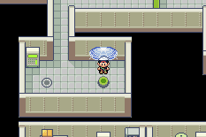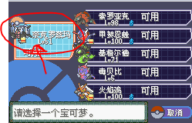

**Find the way go to the right way, this hole is kinda messy**

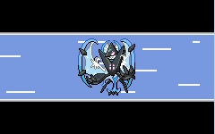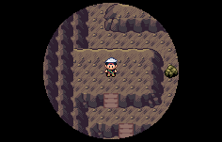

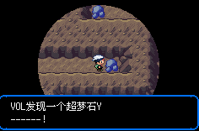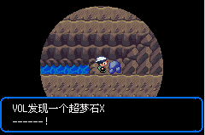

[**Steelix**](https://bulbapedia.bulbagarden.net/wiki/Steelix_(Pok%C3%A9mon)) **stone :Granite Cave3f**

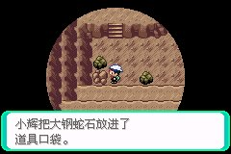

[**Scizor**](https://bulbapedia.bulbagarden.net/wiki/Scizor_(Pok%C3%A9mon)) **stone: Petalburg Woods**

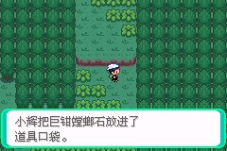

[**Heracross**](https://bulbapedia.bulbagarden.net/wiki/Heracross_(Pok%C3%A9mon)) **stone : road 127**

**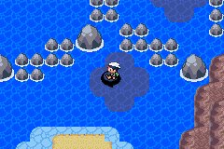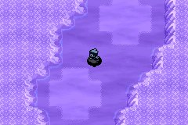  
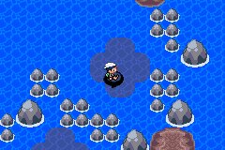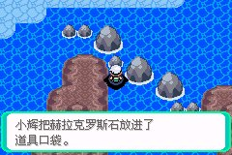**

[**Houndoom**](https://bulbapedia.bulbagarden.net/wiki/Houndoom_(Pok%C3%A9mon)) **stone : Lavaridge Town**

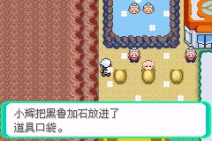

[**Tyranitar**](https://bulbapedia.bulbagarden.net/wiki/Tyranitar_(Pok%C3%A9mon)) **stone:Jagged Pass**

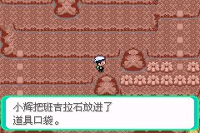

[**Blaziken**](https://bulbapedia.bulbagarden.net/wiki/Blaziken_(Pok%C3%A9mon)) **,** [**Sceptile**](https://bulbapedia.bulbagarden.net/wiki/Sceptile_(Pok%C3%A9mon))**, [Swampert](https://bulbapedia.bulbagarden.net/wiki/Swampert_(Pok%C3%A9mon)" \o "Swampert (Pokémon)) Mega stone:**

**Road 114**

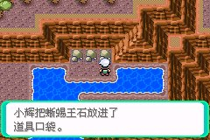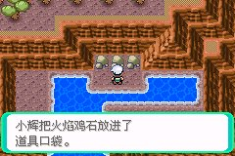

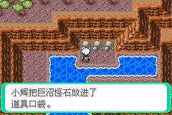

[**Gardevoir**](https://bulbapedia.bulbagarden.net/wiki/Gardevoir_(Pok%C3%A9mon)) **stone =Verdanturf Town**

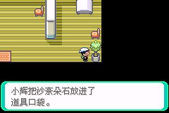

[**Sableye**](https://bulbapedia.bulbagarden.net/wiki/Sableye_(Pok%C3%A9mon)) **stone=Sootopolis City**

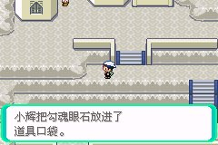

[**Aggron**](https://bulbapedia.bulbagarden.net/wiki/Aggron_(Pok%C3%A9mon)) **stone = Rusturf Tunnel**

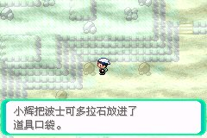

[**Medicham**](https://bulbapedia.bulbagarden.net/wiki/Medicham_(Pok%C3%A9mon)) **stone= Mt. Pyre**

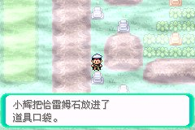

[**Manectric**](https://bulbapedia.bulbagarden.net/wiki/Manectric_(Pok%C3%A9mon)) **stone = road 110**

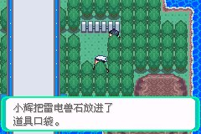

[**Sharpedo**](https://bulbapedia.bulbagarden.net/wiki/Sharpedo_(Pok%C3%A9mon)) **stone = Seafloor Cavern**

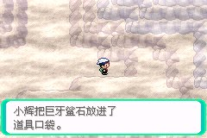

[**Camerupt**](https://bulbapedia.bulbagarden.net/wiki/Camerupt_(Pok%C3%A9mon)) **stone=  [Team Magma Hideout](https://bulbapedia.bulbagarden.net/wiki/Team_Magma_Hideout" \o "Team Magma Hideout)**

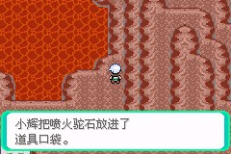

[**Altaria**](https://bulbapedia.bulbagarden.net/wiki/Altaria_(Pok%C3%A9mon)) **stone = Lilycove City**

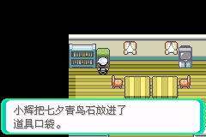

[**Banette**](https://bulbapedia.bulbagarden.net/wiki/Banette_(Pok%C3%A9mon)) **stone = Mt._Pyre**

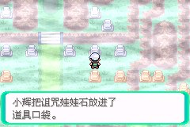

[**Absol**](https://bulbapedia.bulbagarden.net/wiki/Absol_(Pok%C3%A9mon)) **stone= Safari Zone**

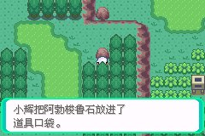

[**Glalie**](https://bulbapedia.bulbagarden.net/wiki/Glalie_(Pok%C3%A9mon)) **stone= Shoal Cave inside**

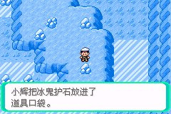

[**Salamence**](https://bulbapedia.bulbagarden.net/wiki/Salamence_(Pok%C3%A9mon)) **stone = Meteor fall**

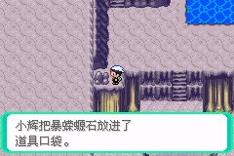

[**Metagross**](https://bulbapedia.bulbagarden.net/wiki/Metagross_(Pok%C3%A9mon)) **stone = Meteor fall**

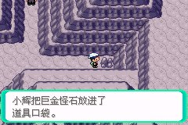

[**Mawile**](https://bulbapedia.bulbagarden.net/wiki/Mawile_(Pok%C3%A9mon)) **stone =121 road**

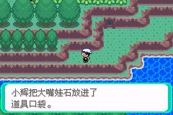

[**Latias**](https://bulbapedia.bulbagarden.net/wiki/Latias_(Pok%C3%A9mon)) **stone & Latios Stone**

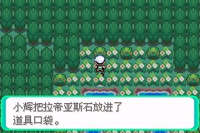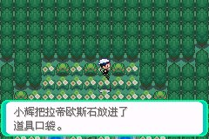

**Groudon -Red Orb & Kyogre Blue Orb at catch place**

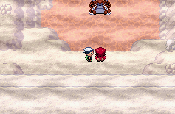

[**Rayquaza**](https://bulbapedia.bulbagarden.net/wiki/Rayquaza_(Pok%C3%A9mon)) **= Meteor Fall learn Dragon Ascent**

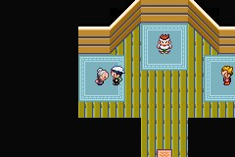

[**Lopunny**](https://bulbapedia.bulbagarden.net/wiki/Lopunny_(Pok%C3%A9mon)) **stone : CASINO**



[**Garchomp**](https://bulbapedia.bulbagarden.net/wiki/Garchomp_(Pok%C3%A9mon)) **Stone : Fortree City**

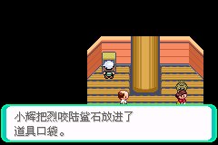

[**Lucario**](https://bulbapedia.bulbagarden.net/wiki/Lucario_(Pok%C3%A9mon)) **Stone: • [Lilycove City](https://bulbapedia.bulbagarden.net/wiki/Lilycove_City" \o "Lilycove City)**

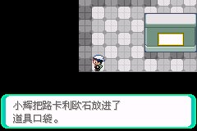

**A**[**bomasnow**](https://bulbapedia.bulbagarden.net/wiki/Abomasnow_(Pok%C3%A9mon)) **Stone =123 road**

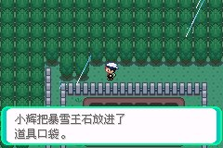

[**Gallade**](https://bulbapedia.bulbagarden.net/wiki/Gallade_(Pok%C3%A9mon)) **Stone = Fallarbor Town**



[**Audino**](https://bulbapedia.bulbagarden.net/wiki/Audino_(Pok%C3%A9mon)) **Stone : Battle Frontier**

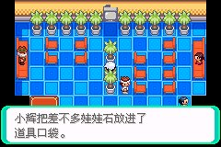

[**Diancie**](https://bulbapedia.bulbagarden.net/wiki/Diancie_(Pok%C3%A9mon)) **Stone: Battle Frontier**

